

Name: Hafiz Waseem Ahmed
S/O: Abdul Karim
Semester: 5th
Session: 2023-2027
Dept: Computer Science
Subject: Computer Vision
Submitted to: Dr. Abdul Basit
Date: 22-6-2026

Signature: ____________

Computer Vision Assignment 4
Filtering And Edge Detection
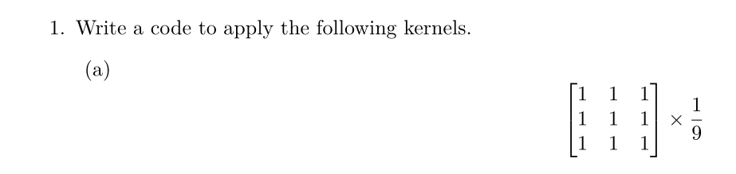
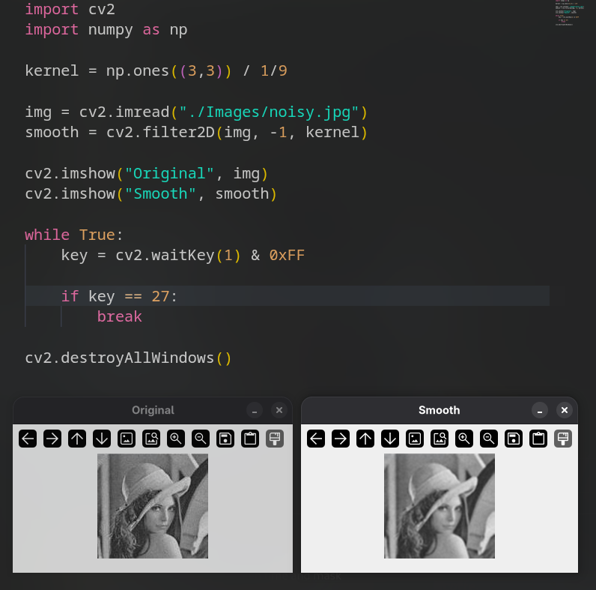

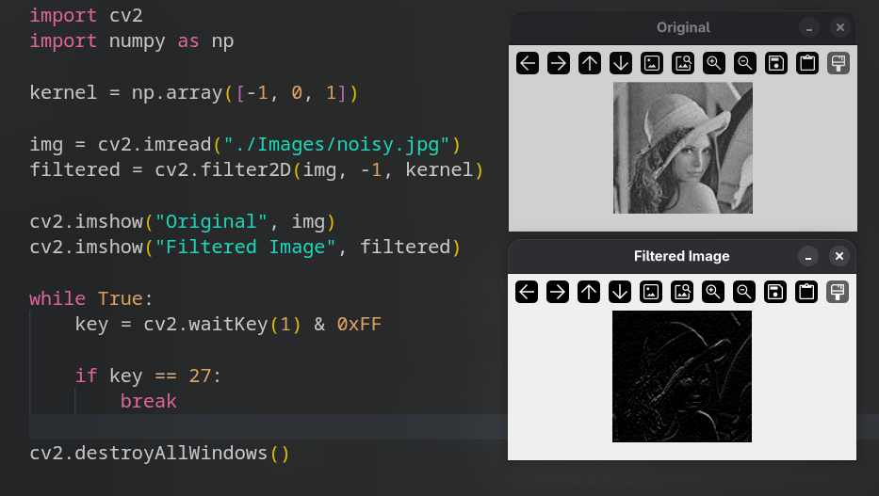

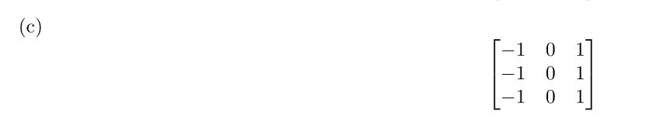

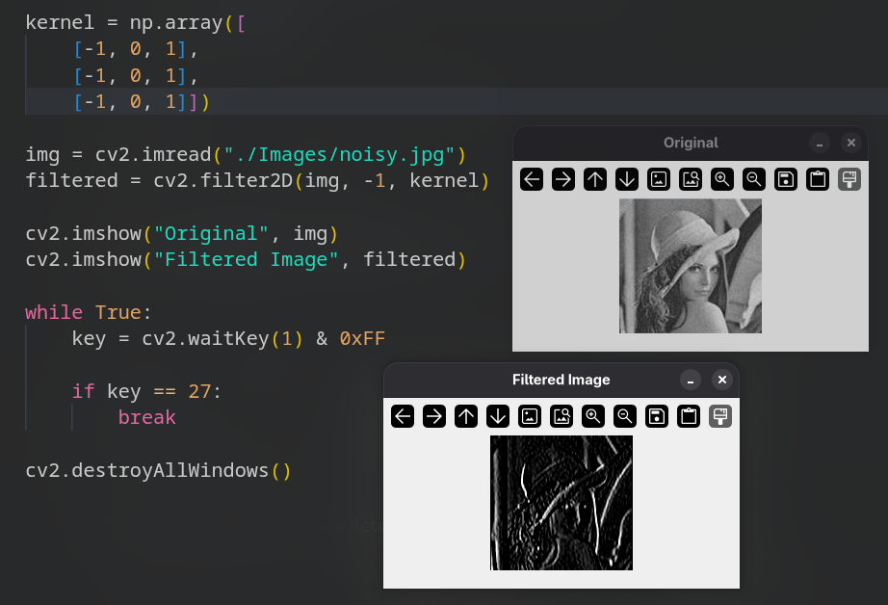

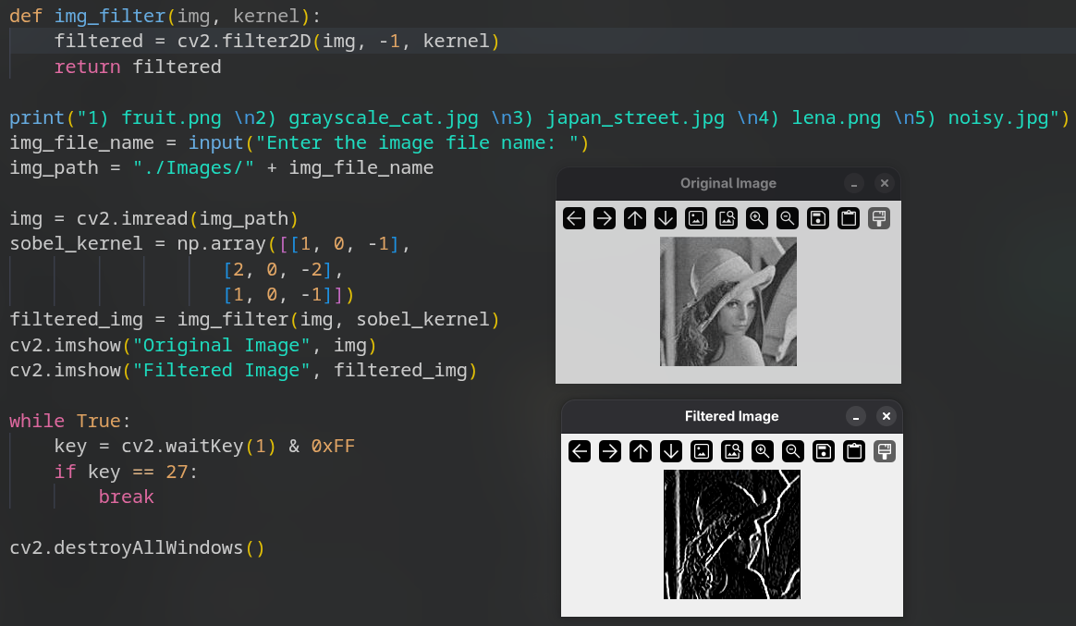
2)_Define a function that takes an image and kernel as an argument and return the resultant image.
3) Do the following.
(a) Derivate in x and y.
(b) Find the Magnitude M.
(c) Threshold the image.
